Generating BOOT.bin image:

* Decide what HW you want to be loaded into the system on startup, this is represented by the **HWA_func_bitstreams.bit** file witch is created while executing make_dcp.tcl script on a specific accelerator.
* Go to: <http://www.wiki.xilinx.com/Zynq+Releases> this site contains downloads for PetaLinux for the xc702/706 based boards.
* Download a release you want to work with (2014.2 is tested and working).
* Open the file and Extract the contents of the tar file (this will be the extraction folder).
* Open Xilinx SDK.
* Click "Xilinx Tools" and select "Create Zynq Boot Image"
* In "output BIF file path" write the file path to save the configuration (optional).
* In Output path write the path to the BOOT.bin file you want to create.
* Click add  
  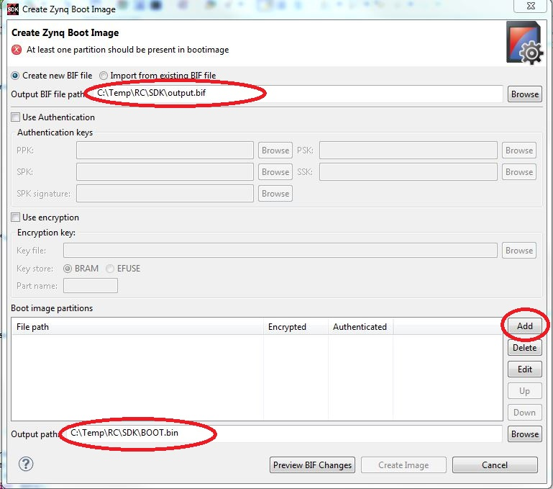
* In "File path" enter the path for the fsbl.elf file from   
  <extraction folder>\zc70x\zc702\fsbl.elf (or brows to it) example:  
  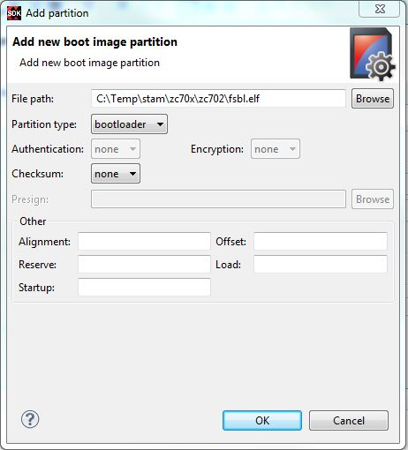
* Click ok.
* Click add again and add the HWA_func_bitstreams.bit file you selected.
* Click ok.
* Click add again and add the u-boot.elf file located on   
  <extraction folder>\zc70x\u-boot.elf
* Click ok. Example:  
  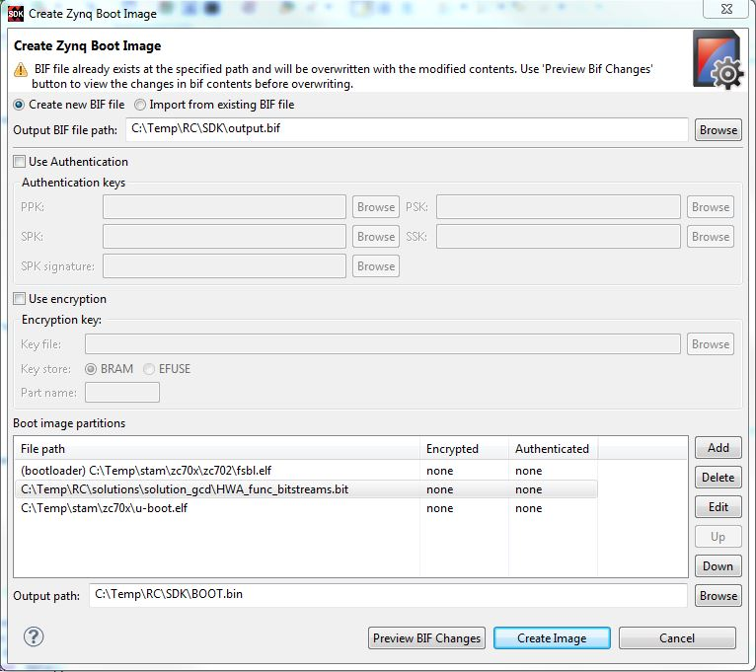
* Click "Create Image"

Note: To boot from the SD card you need the following files to be on it:

* **BOOT.bin** that we just created
* **uImage** file that is located at <extraction folder>
* **uramdisk.image.gz** file that is located at <extraction folder>
* **devicetree.dtb** file that is located at <extraction folder> \zc70x\zc702